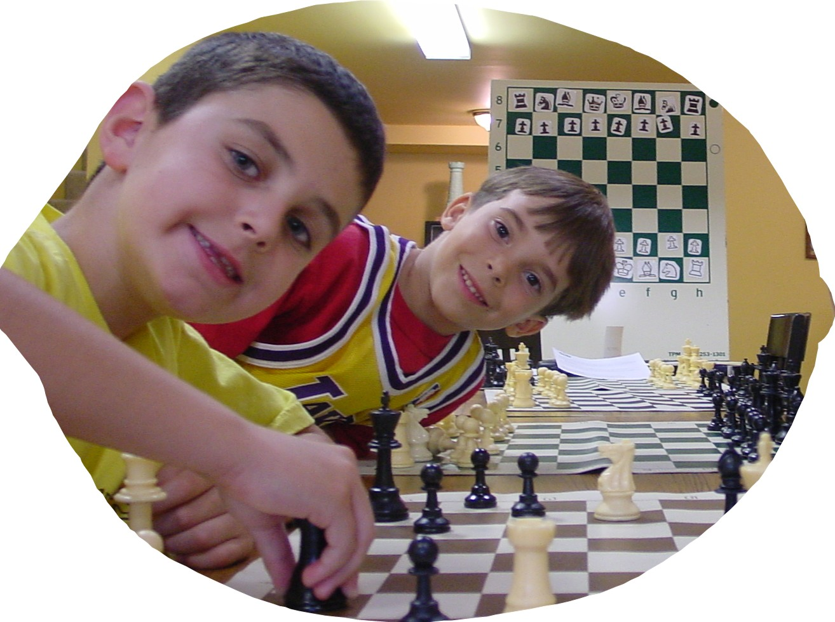
Small Group (Evening)
Chess Classes At CYCL
Six-Week Sessions (once per week)
$68 per child, 2 for $108, 3 for $120

Class size is typically between 5 and 14 students.
Introduction to Chess (offered every other session). Next session begins April 13th or 14th
For players who are new to the game or have very little knowledge
Days & Times: Wednesdays, 6:15-7:15pm • Thursdays, 4:30-5:30pm
Subjects: Piece introduction • Check & Checkmate • Castling • Escaping •En Passant Capture • Common Checkmate •Draws - Players receive a lesson book with class!

These classes are offered every 6 weeks. Next session begins the week of April 11th
Beginning Strategies (first day is April 13th or 15th)
For players who are past the Intro Level but have not taken Small Group Classes before
Days & Times: Wednesdays, 5-6pm • Fridays, 5-6pm
Subjects: Basic Checkmates • General Opening Guidelines • Endgame Strategies • More!

Intermediate Instruction (first day is April 11th or 15th)
For players who have a firm grasp of the subjects in the Beginning Strategies Class
Days & Times: Mondays, 5:00 - 6:15pm • Fridays, 6 – 7:15pm
Subjects: Positional Ideas • Checkmate Patterns • Opening Traps • Common Endgame Tricks • Tactical Review • Light Game Study • Computer Drills • USCF Tourney Prep

Advanced -You know who you are! (first day is April 11th or 15th)
Days & Times: Mondays, 6:30 - 8pm • Fridays, 7:30 – 9pm
Subjects: Intense Game Analyzation • Complex Checkmate Patterns • Specific Opening Variations • Advanced Endgame Strategies • Tournament Psychology • More!
-------------------------------------------- (cut here) ---------------------------------------------------------------
Student Name ________________________ Parents’ Names _________________
School _________________________________________ Grade (as of Fall ’04) ____
Allergies or other medical __________________________ D.O.B. ____ / ____ / ____
Street Address _______________________ City _______________ Zip _______
Phone Numbers _______________ ______________ Email ___________________
Class (circle one): Intro Beg Inter Adv Day (circle one): Mon Wed Thur Fri
Please make checks to CYCL and mail or drop-off.
Please call ahead to verify room in the Friday Inter (6pm) class as it usually fills up.
CYCL • 25864 Tournament Rd., Suite G • Valencia, CA 91355
(661) 288-1705 • coachjay@cycl.org • www.cycl.org
Apr-May ‘05

